Technical Report - Project specifications

PocketHome
Course: | IES - Introdução à Engenharia de Software
Date: | Aveiro, 19th december 2019
Students: | 90514: Rodrigo França Oliveira  89341: Daniel José Matias Pinto  89296: Tomás dos Santos Batista  88887: Flávia Gomes Figueiredo  87456: José Carlos Martins de Mello Filho
Project abstract: | PocketHome is a web browser application that allows you to monitor your house from anywhere, anytime.

Table of contents:
1 Introduction
2 Product concept
Vision statement
Personas
Main scenarios
3 User Case Diagram
Key requirements and constraints
Architectural view
Module interactions
4 Information perspective
5 References and resources

1 Introduction
The popularity of smart homes has been increasing greatly in recent years, due to considerable affordability and simplicity through smartphone and tablet connectivity.
An home automation integrates electrical devices in a house with each other. In our case, we will use sensors connected on a single platform.
Pockethome is an application that allows you to analyze sensor data, such as: temperature and humidity of your house, temperature of your city, check for raining, door status (closed, open), lights (on, off), flame detection and temperature graph. It was designed with the purpose of monitoring the entire residence and to give the user the best way to assure security of the home, by having control over it.

2 Product concept

Vision statement
A web browser page that allows you to monitor your home system from anywhere, anytime. Pockethome can let you know the temperature of your city (IPMA API), monitor the temperature and humidity of your home, can let you know if there are lights on, any flame leaks, door status and raining status. Through the integration of information technologies with the various sensors scattered around your house, system and appliances can communicate in an integrated manner which results in convenience, safety benefits and energy efficiency.

Objectives
The main objectives of our project are as follow:
- To remotely monitor home appliances.
- To utilize energy efficiently and save time.
- To ensure the correct status of the house.

Project Features
The features of our project can be highlighted in following points:
- Remote monitor of home appliances from anywhere using the website (can be accessed through mobile).
- Considerable reduction in electricity bills with efficiency energy utilization.
- Continuous monitoring and security of home with sensors.

Personas


Persona 1
Alberto is a 44 year old man who owns a hardware store in Águeda. Alberto finished high school and started working right away car parts factory until he opened his own hardware store 10 years ago. With 2 kids, the environment around the house can get very busy.
Recently, when leaving the house to drop his kids at school, Alberto forgot to close the front door. Fortunately no one got into the house and everything was the way it was left, but it got Alberto thinking on how this could have gone wrong. Since then Alberto has been very careful with closing the doors but throughout the day he still doubts himself if he really left the doors open or not.
Motivation: Alberto would like to know if he left the doors open when he leaves the house.


Persona 2
José is a 39 year old man that lives in Aveiro. José considers himself a successful man. He was able to finish his computer science degree without retaking classes and with very high grades. When he finished his degree, a software company based in Porto hired him and he worked there for 10 years. During those years he gained a lot of knowledge and experience which gave him the courage to start his own company. 2 years ago he bought a house in Portimão with the intent of that being a summer/vacation house. In his last summer vacation he arrived in Portimão to find out that the house had a small fire.
Motivation: José would like to receive a notification when the fire sensors are activated.


Persona 3
Matilde is 35 year old woman that works as a chef in a restaurant in Aveiro. Even though she works in Aveiro, she lives in Águeda. In a regular work week, her day starts by dropping her son in school, going to the gym and finally arriving in the restaurant.
Recently her house got hit by a plague damaging part of the walls. Once she started noticing the plague and the damages, she immediately called a disinfestation team. The team completely removed the plague and gave instructions to Matilde to keep the humidity in the house around 40% and the temperature around 20ºC.
Motivation: Matilde would like to check the values of humidity and temperature throughout the house.

All the personas and use cases were tracked on the Pivotal Tracker. The use cases were then converted into Features to implement on the website. The To-Do and task assignment were tracked using GitHub Projects. Task assignment was dictated by our project leader (Flávia), and were updated every week after our practical class in a Scrum-Like meeting. We also used Branch-Feature in our repository, to make it easier the process of developing our app.

Main scenarios
Alberto checks if the doors are locked: After logging in the page, Alberto is redirected to the front page where he is welcomed to the website. He then presses the login button and is redirected to the dashboard where he can check if the doors were left close or open.

José checks the fire sensor: José logs in the page and checks the fire sensor. He then visualizes if there was any fire alarm.

Matilde checks the temperature and humidity around the house: Matilde logs in the page and in the dashboard can check the temperature, the humidity and also a graph of the historical temperatures.

3 User Case Diagram

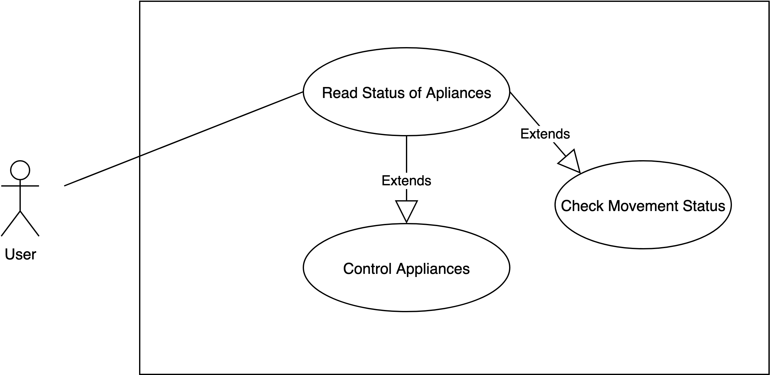
In our system, user acts as a primary actor who can read status of appliances through the application.

Key requirements and constraints
There are some key requirements and system constraints that have a significant bearing on the architecture. They are:
- Are the sensors easy to implement or not, due the fact we never worked with raspberry pi and sensors.
- Product utility considering if its implementation would bring any valuable customer return.
- The PocketHome registration System must ensure complete protection of data from unauthorized access. All accesses are subject to user identification and password control.
- A database architecture that supports the operational needs of our application as well as its reporting needs. A design process where the goal is to ensure that data is stored in one and one place only. Capability to store and get all different information data of each sensor.
- A web page design that can present client the assignment we worked with, showing our client that we understood his needs.

Architectural view
There are two major pieces in this project. First one is the server part, which is where our API is running alongside our website’s program, database and the receiver of the RabbitMQTT. The other one is the sensors and raspberry part. The raspberry collects the values from the sensors and sends them to the server part, through RabitMQTT. The server then will store them with POST’s to the API. All the messages are parameterized to better control.
Web page is capable of nicely presenting the current status of the home sensors. The webpage receives the values from the Database through API.
Everything that it’s running on the server side (Spring project, Postgres and receiver it’s running on docker, so it’s 24/7 available).

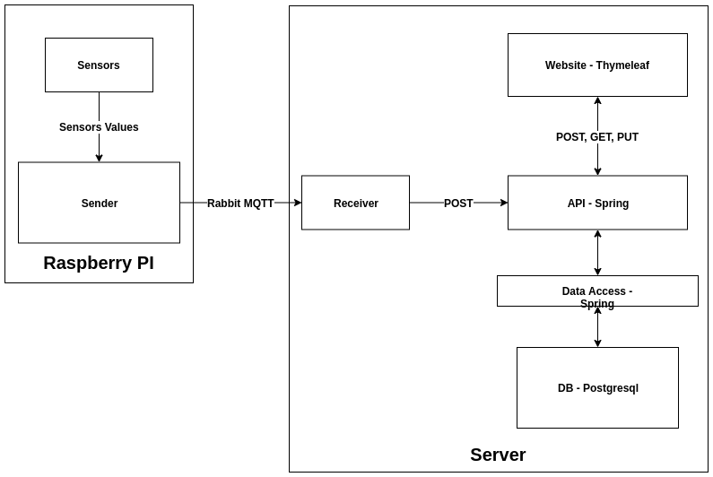

Module interactions
- Raspberry pi collects values from sensors.
- Raspberry sends the values from the sensors in a structured message, through RabbitMQTT, to the server side.
- API save information data in database.

Activity Diagram
The activity diagram below shows the flow of activities or actions that occur when the user tries to interact with the system and tries to access the functionalities provided by the system. At the same time, the sensors sends new data to the database.

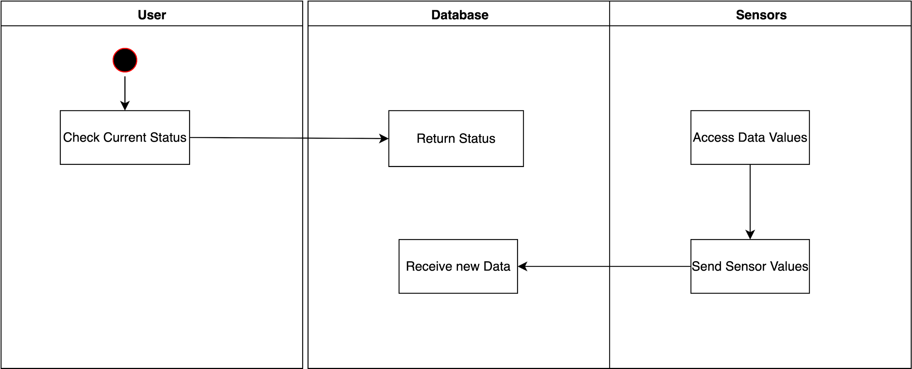

The user’s request is independent from the input of new values, the input of new data, which occurs sporadically, when actions occur.

Sequence Diagram
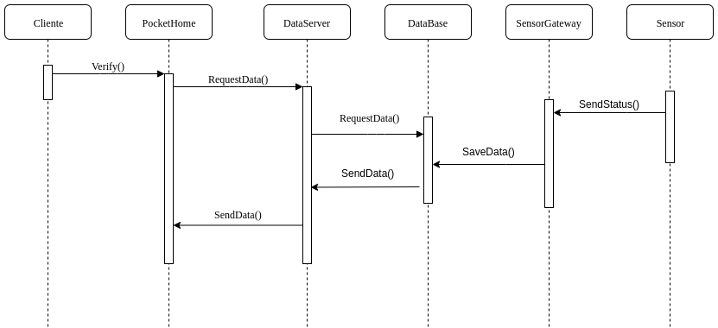

First of all, the user checks the current status of Pockethome appliances in the website. If there are new values the page will refresh the sensors send news status to the database. Raspberry pi continuously checks the status values in the database and as soon as new status gets stored in the database a new one will be sent.

4 Information perspective

Logical Model
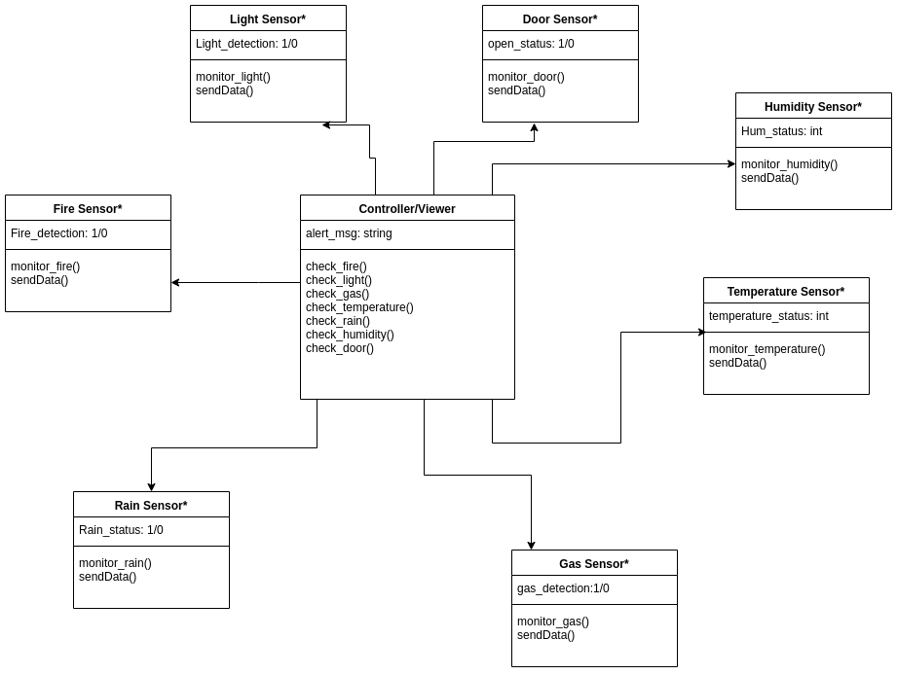
Through the controller/viewer will be possible to have the information of sensors installed in the house, and their values stored in the database.

5 References and resources
GitHub
API Postman
GPIO Documentation

Conclusion
The output of this project is an array of home sensors that are used to monitor homes over the internet with the help of a web page.
This project has been a great experience for authors to have the opportunity to closely experiment and learn about what goes in in a professional environment and what it is like to develop an application with extensive data processing. Also, it was great to work in a project with a team with 5 members to have a sense of team working.
We started with the ambition of more sensors, along the process we accidentally burned one and destroyed another one. Although, the final balance is positive, we have a stable application which includes hardware (it’s a plus) and a well-working website.

